SSIS & SQL Server Project.

Group 2: Safa, Ekaterina, Zhassulan, Charles.

Chosen model: star.

Schema:

SQL scripts to create tables: in Tables_creation.sql.

1. **STA : load source data.**

First we create STA_project database in SQL.

Departments :

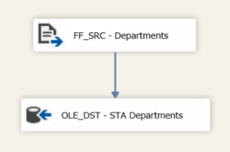

Result file:

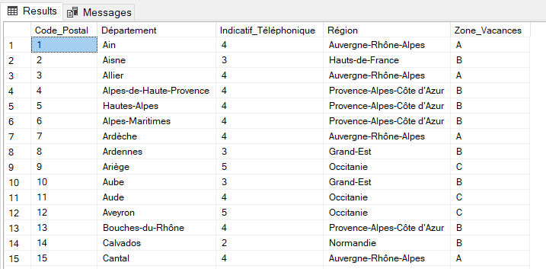

Crimes :

Creating variables to hold each worksheet name:

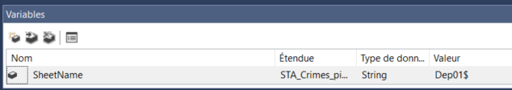

Add a loop Foreach Loop Container:

* Foreach ADO.NET Schema Rowset Enumerator
* Connection: MS Jet 4.0 OLE DB Provider
* Extended Properties “Excel 8.0”
* Variable Mapping “User::SheetName 2”

Add a data flow task within the loop.

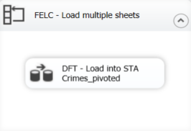

In the data flow:

* Add derived column “Department” with “(DT_WSTR,50)(SUBSTRING(@[User::SheetName],1,LEN(@[User::SheetName]) - 1))” to transform sheets names on column.

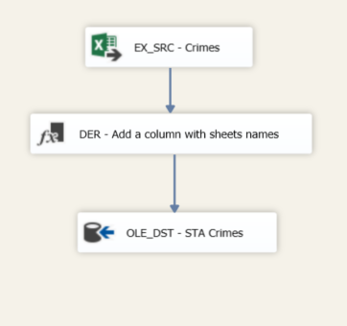

Result table:

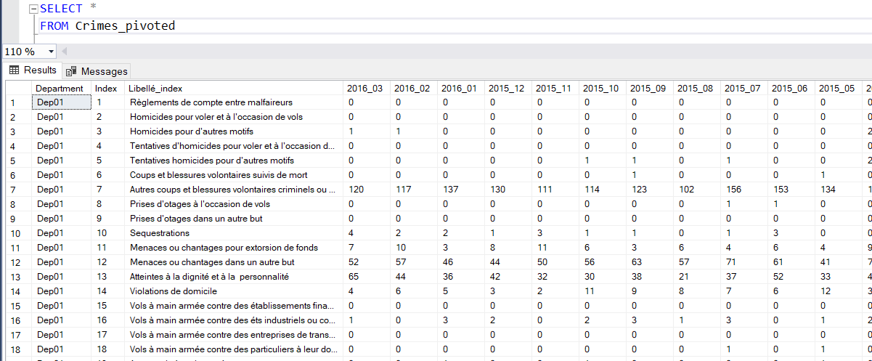

1. **ODS : transforamtions.**

Create ODS_Project database in SQL.

Departments :

We will not keep Phone code and Vacations zone as not related to crimes.

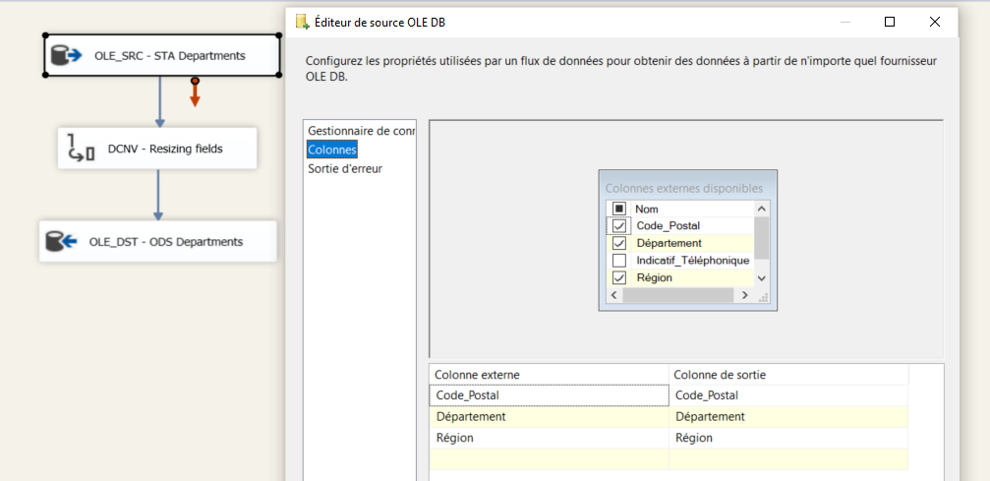

Derived column to format Department (Code_Postal): “RIGHT("00"+[Code_Postal]**,2**)” – to add 0 for first 9.

Resizing:

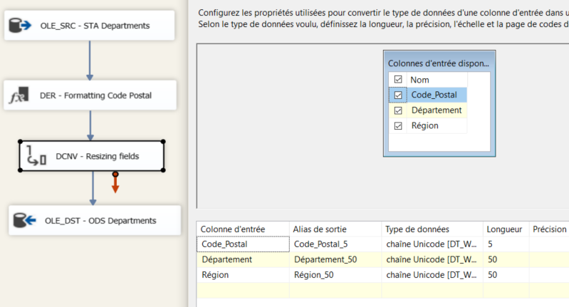

All transformations:

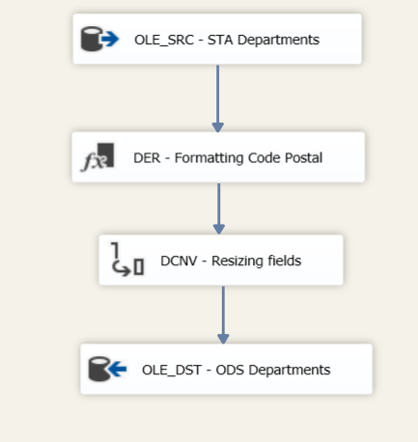

Result file:

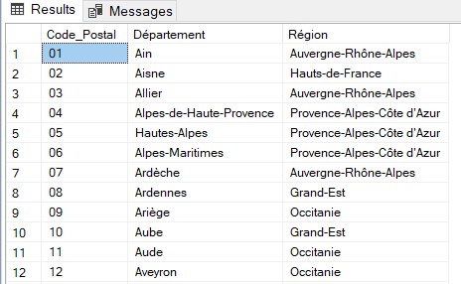

Crimes :

Unpivot:

We want to transform all columns with dates in one.

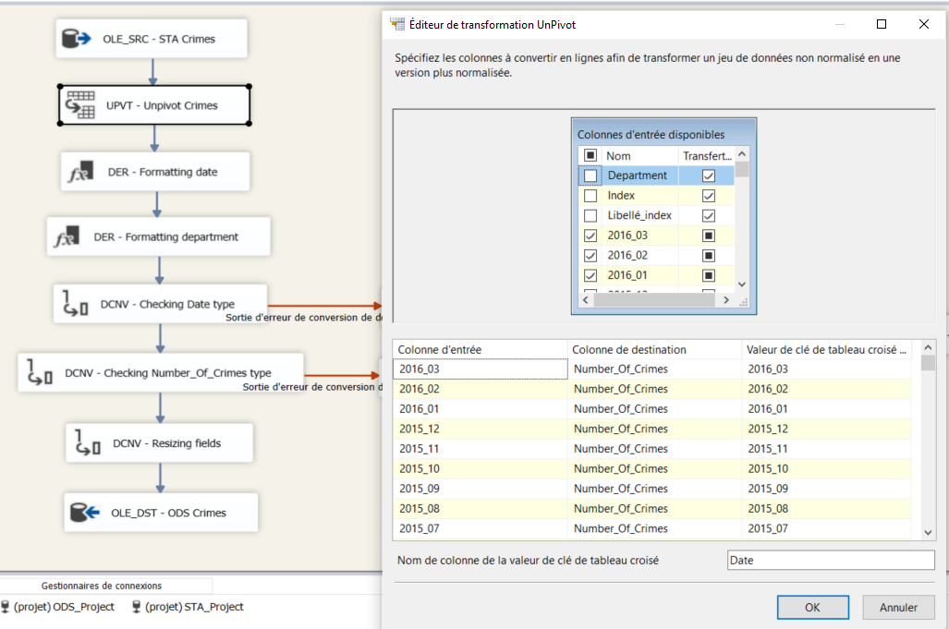

Derived column to format date: “(DT_DATE)(SUBSTRING(Date,1,4) + "-" + SUBSTRING(Date,6,2) + "-" + "01")”;

Derived column to format department: “(DT_WSTR,50)(DT_I8)SUBSTRING(Department,4,2)” (Delete Dep and leading 0);

Transform date in “date [DT_DATE]” and number of crimes to “INT”.

Put date errors and non-numeric crimes numbers in Technical rejects table:

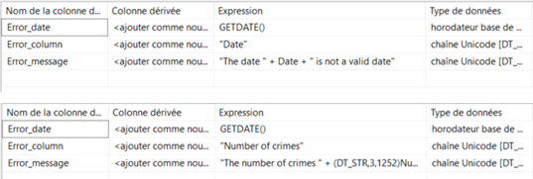

Resizing the rest fields:

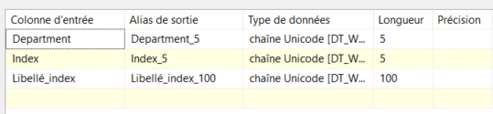

All transformations:

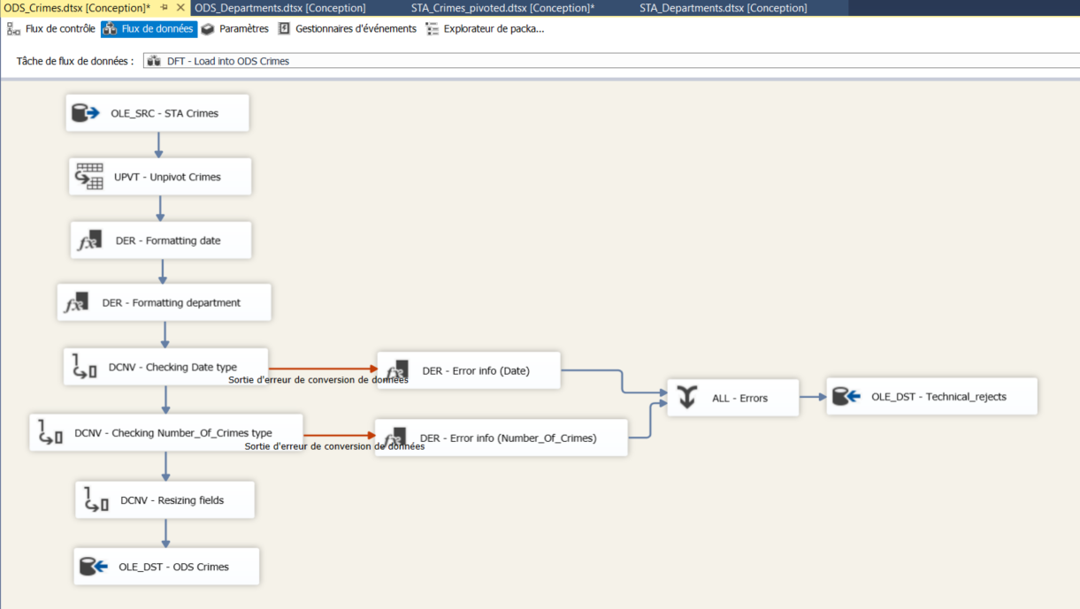

Result file:

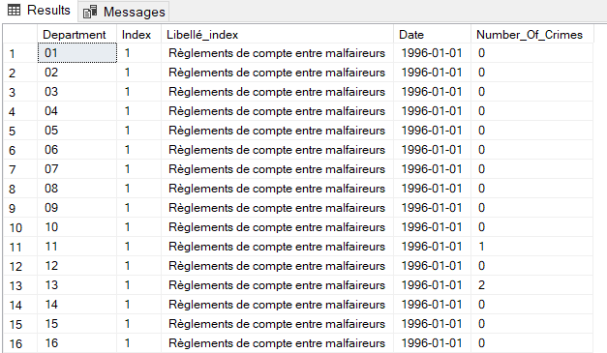

Technical rejects: (there were not created any).

1. **DWH**

Create DWH_Projet database in SQL.

Dim tables: Date, Libellé (name of crimes), Department.

Fact table: Crimes (keys from dim tables + number of crimes)

DimDate :

SQL script in SQL Script – DimDate.sql.

Result file:

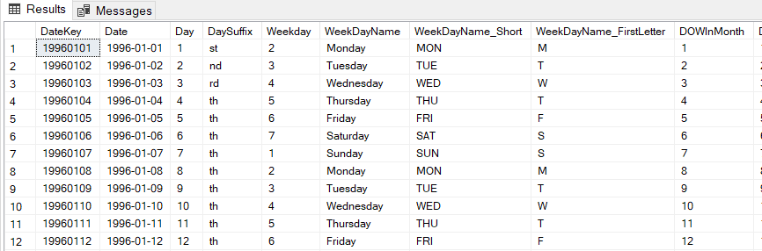

DimLibelle :

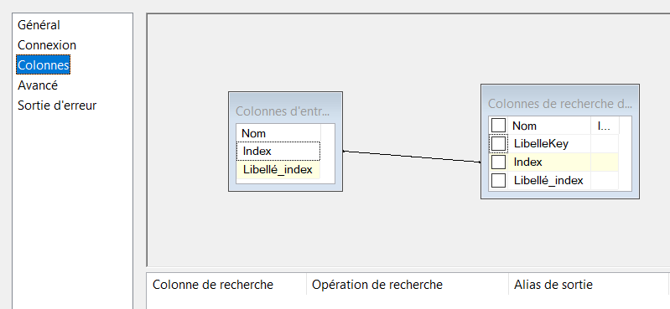

For the case if libellé did not existed or were modified:

UPDATE [dbo].[DimLibelle]

SET

[Libellé_index] = ?

WHERE [Index] = ?

All transformations:

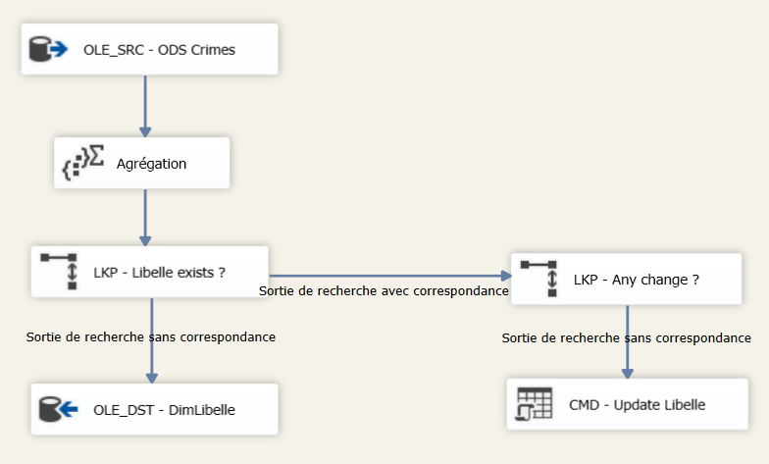

Result file:

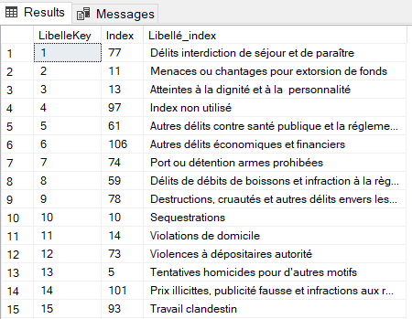

DimDepartments :

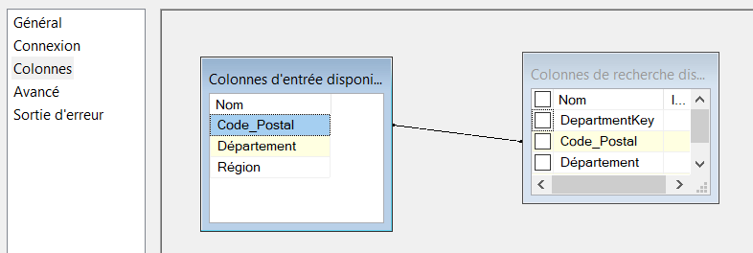

For occasional modified records:

UPDATE [dbo].[DimDepartments]

SET

[Département] = ?

[Région] = ?

WHERE [Code_Postal] = ?

All transformations:

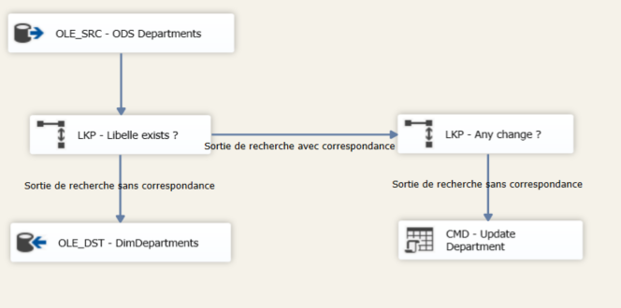

Result file:

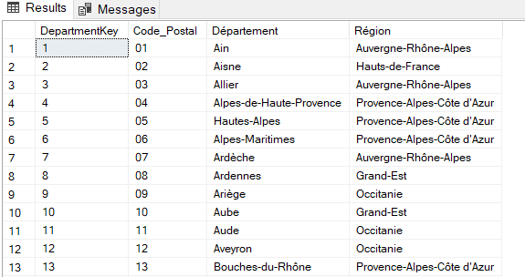

FactCrimes :

All transformations:

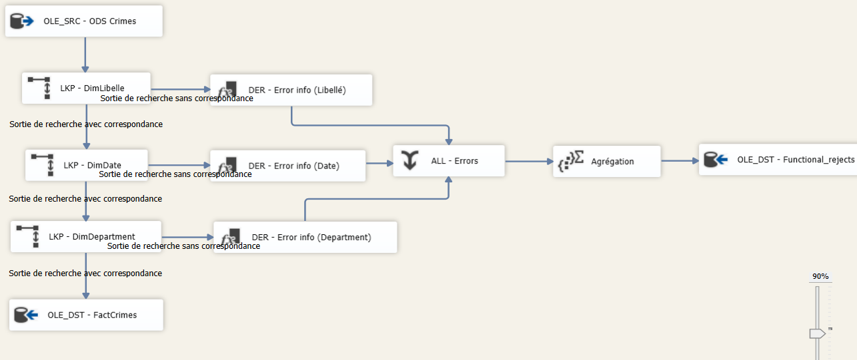

Functional rejects:

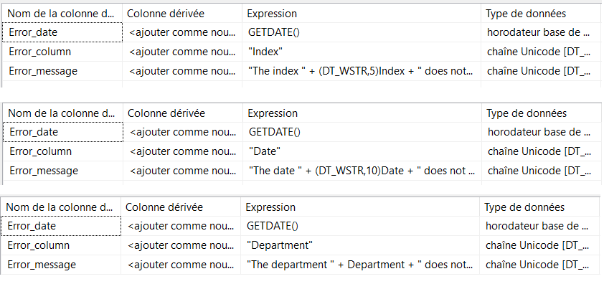

Some rows rejected, 1 department was in Crimes and not in Departments source:

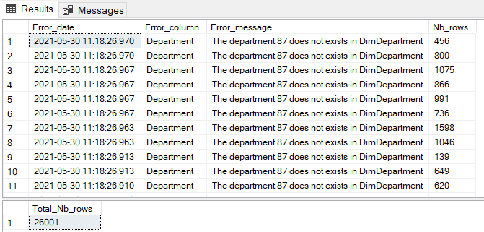

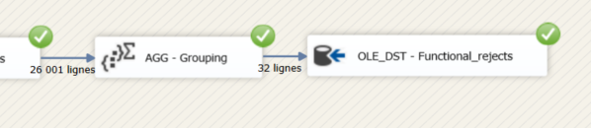

Result file:

